**VideoRecorder**

Исходный код проекта:

<https://github.com/verkhoumov/AndroidLabs/tree/master/VideoRecorder>

Скриншоты экрана:

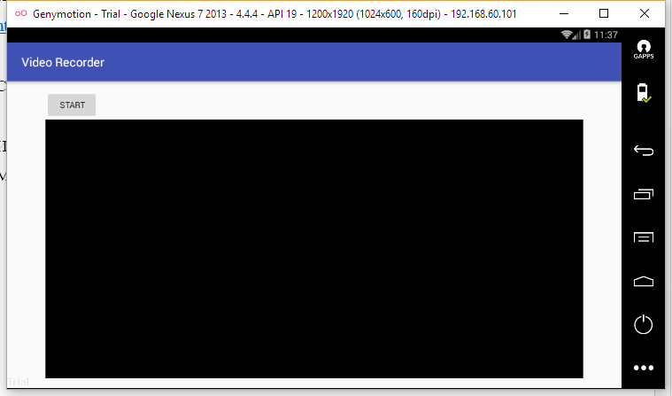

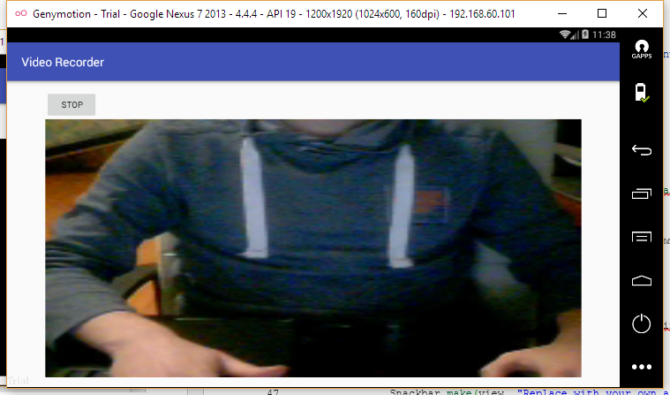

Исходный код.

MainActivity.java:

1. **package** ru.verkhoumov.videorecorder;
3. **import** android.media.MediaRecorder;
4. **import** android.os.Environment;
5. **import** android.support.v7.app.AppCompatActivity;
6. **import** android.os.Bundle;
7. **import** android.support.v7.widget.Toolbar;
8. **import** android.view.SurfaceHolder;
9. **import** android.view.SurfaceView;
10. **import** android.view.View;
11. **import** android.widget.Button;
13. **import** java.io.File;
14. **import** java.io.IOException;
16. **public** **class** MainActivity **extends** AppCompatActivity {
17. **private** MediaRecorder mediaRecorder;
18. **private** File outputDir;
19. **private** **boolean** recording = **false**;
21. @Override
22. **protected** **void** onCreate(Bundle savedInstanceState) {
23. **super**.onCreate(savedInstanceState);
24. setContentView(R.layout.activity_main);
26. File moviesDir = Environment.getExternalStoragePublicDirectory(Environment.DIRECTORY_MOVIES);
28. outputDir = **new** File(moviesDir, "VideoRecorder");
29. outputDir.mkdirs();
30. }
32. @Override
33. **protected** **void** onResume() {
34. **super**.onResume();
36. mediaRecorder = **new** MediaRecorder();
38. initAndConfigureMediaRecorder();
39. }
41. @Override
42. **protected** **void** onPause() {
43. **super**.onPause();
45. **if** (recording) {
46. **try** {
47. mediaRecorder.stop();
48. } **catch** (IllegalStateException e) {
49. e.printStackTrace();
50. }
51. }
53. releaseMediaRecorder();
55. Button button = (Button) findViewById(R.id.button);
56. button.setText("Start");
58. recording = **false**;
59. }
61. **private** **void** releaseMediaRecorder() {
62. **if** (mediaRecorder != **null**) {
63. mediaRecorder.reset();
64. mediaRecorder.release();
65. mediaRecorder = **null**;
66. }
67. }
69. **private** **void** initAndConfigureMediaRecorder() {
70. mediaRecorder.setAudioSource(MediaRecorder.AudioSource.CAMCORDER);
71. mediaRecorder.setVideoSource(MediaRecorder.VideoSource.CAMERA);
72. mediaRecorder.setOutputFormat(MediaRecorder.OutputFormat.MPEG_4);
73. mediaRecorder.setVideoFrameRate(10);
74. mediaRecorder.setVideoEncoder(MediaRecorder.VideoEncoder.MPEG_4_SP);
75. mediaRecorder.setAudioEncoder(MediaRecorder.AudioEncoder.AMR_NB);
77. String outputFile = **new** File(outputDir, System.currentTimeMillis() + ".mp4").getAbsolutePath();
78. mediaRecorder.setOutputFile(outputFile);
80. SurfaceView surfaceView = (SurfaceView) findViewById(R.id.videoView);
81. SurfaceHolder surfaceHolder = surfaceView.getHolder();
82. mediaRecorder.setPreviewDisplay(surfaceHolder.getSurface());
83. }
85. **public** **void** startStopRecording(View view) {
86. Button button = (Button) findViewById(R.id.button);
88. **if** (recording) {
89. button.setText("Start");
91. **try** {
92. mediaRecorder.stop();
93. } **catch** (IllegalStateException e) {
94. e.printStackTrace();
95. }
97. releaseMediaRecorder();
98. } **else** {
99. button.setText("Stop");
101. **if** (mediaRecorder == **null**) {
102. mediaRecorder = **new** MediaRecorder();
103. initAndConfigureMediaRecorder();
104. }
106. **try** {
107. mediaRecorder.prepare();
108. } **catch** (IllegalStateException e) {
109. e.printStackTrace();
110. } **catch** (IOException e) {
111. e.printStackTrace();
112. }
114. mediaRecorder.start();
115. }
117. recording = !recording;
118. }
119. }

activity_main.xml:

1. **<?xml** version="1.0" encoding="utf-8"**?>**
2. **<LinearLayout** xmlns:android="http://schemas.android.com/apk/res/android"
3. xmlns:tools="http://schemas.android.com/tools"
4. android:id="@+id/content_main"
5. android:layout_width="match_parent"
6. android:layout_height="match_parent"
7. android:paddingBottom="@dimen/activity_vertical_margin"
8. android:paddingLeft="@dimen/activity_horizontal_margin"
9. android:paddingRight="@dimen/activity_horizontal_margin"
10. android:paddingTop="@dimen/activity_vertical_margin"
11. android:orientation="vertical"
12. tools:context="ru.verkhoumov.videorecorder.MainActivity"**>**
14. **<Button**
15. android:id="@+id/button"
16. android:layout_width="wrap_content"
17. android:layout_height="wrap_content"
18. android:onClick="startStopRecording"
19. android:text="START" **/>**
21. **<SurfaceView**
22. android:id="@+id/videoView"
23. android:layout_width="match_parent"
24. android:layout_height="match_parent" **/>**
25. **</LinearLayout>**

AndroidManifest.xml:

1. **<?xml** version="1.0" encoding="utf-8"**?>**
2. **<manifest** xmlns:android="http://schemas.android.com/apk/res/android"
3. package="ru.verkhoumov.videorecorder"**>**
5. **<uses-feature** android:name="android.hardware.camera" **/>**
6. **<uses-feature** android:name="android.hardware.camera.autofocus" **/>**
7. **<uses-permission** android:name="android.permission.RECORD_AUDIO" **/>**
8. **<uses-permission** android:name="android.permission.CAMERA" **/>**
9. **<uses-permission** android:name="android.permission.WRITE_EXTERNAL_STORAGE" **/>**
11. **<application**
12. android:allowBackup="true"
13. android:icon="@mipmap/ic_launcher"
14. android:label="@string/app_name"
15. android:supportsRtl="true"
16. android:theme="@style/AppTheme"**>**
17. **<activity**
18. android:name=".MainActivity"
19. android:screenOrientation="landscape"**>**
20. **<intent-filter>**
21. **<action** android:name="android.intent.action.MAIN" **/>**
23. **<category** android:name="android.intent.category.LAUNCHER" **/>**
24. **</intent-filter>**
25. **</activity>**
26. **</application>**
27. **</manifest>**